Day 15 Lab

Question to be solved

VIP Customer Outage Escalation Engine (CSM)
Business Requirement
If VIP customer opens multiple high priority cases within 1 hour:
• auto escalate
• Create management notification
• Assign special response team
________________________________________
Module
CSM → Case Management
________________________________________
Tables Used
• sn_customerservice_case
• customer_account
________________________________________
Custom Fields
Field Type
u_vip_escalated True/False
u_outage_detected True/False
________________________________________
Execution Flow
VIP customer opens case
↓
System checks recent cases
↓
Find high priority cases in last 1 hour
↓
If count >= 3:
Detect outage pattern
Escalate case
Notify management
Assign rapid response team
________________________________________
Validation Rules
1. Customer Must Be VIP
Only VIP accounts trigger escalation engine
________________________________________
2. Only High Priority Cases
Priority must be Critical
________________________________________
Expected Automation
Case Update
u_outage_detected = true
u_vip_escalated = true
________________________________________
Assignment
VIP Rapid Response Team
________________________________________
Event
vip.customer.outage.detected

Answers and steps
Created a VIP flag to know if the user is VIP in Account Table
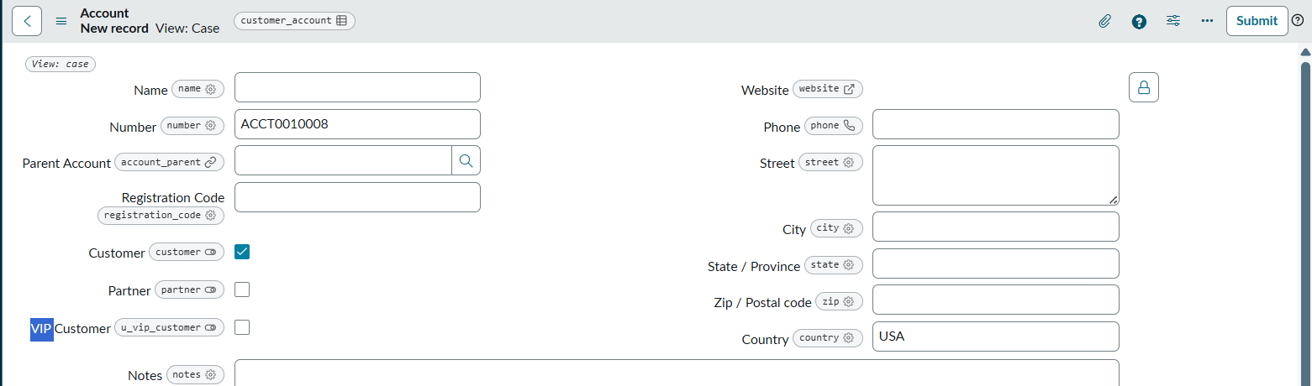

Created the required group to be assigned to
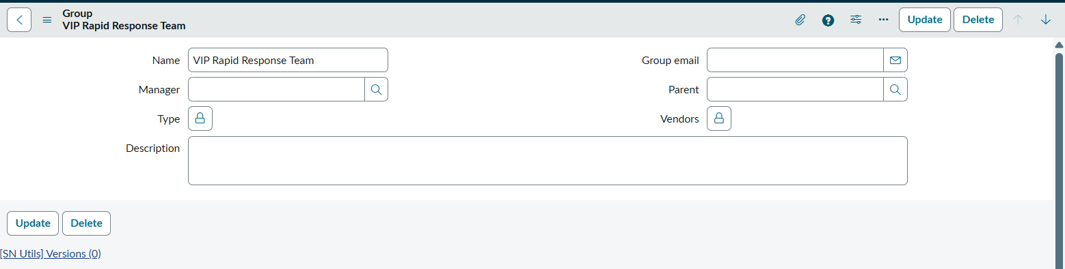
Added the custom fields to detect for escalation 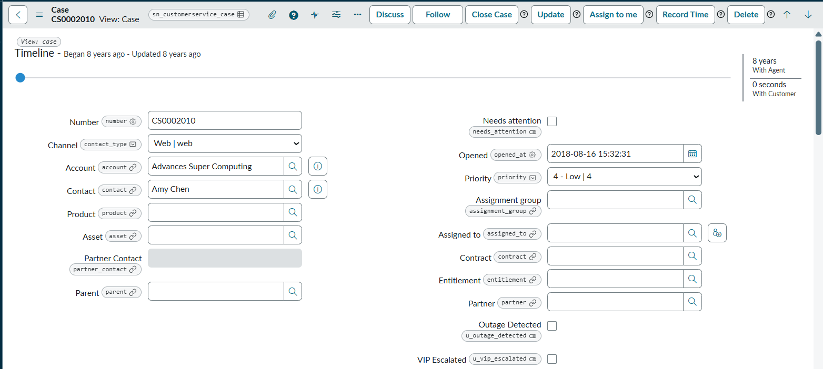

Answer Script
Created an After Business rule to maintain this scenario

(function executeRule(current, previous) {
gs.addInfoMessage('Business Rule Started');
if (current.priority != 1) {
gs.addInfoMessage('Case is NOT Critical');
return;
}
gs.addInfoMessage('Critical Case Confirmed');
if (!current.account) {
gs.addInfoMessage('No Account Selected');
return;
}
gs.addInfoMessage('Account Found');
var accountGR = new GlideRecord('customer_account');
accountGR.addQuery('sys_id',current.account);
accountGR.query();
if(accountGR.next()){
gs.addInfoMessage('VIP Field Value = ' + accountGR.u_vip_customer);
}
if (!accountGR.get(current.account)) {
gs.addInfoMessage('Customer Account Not Found');
return;
}
gs.addInfoMessage('Customer Account Retrieved');
if (!accountGR.u_vip_customer) {
gs.addInfoMessage('Customer is NOT VIP');
return;
}
gs.addInfoMessage('VIP Customer Confirmed');
var caseGR = new GlideRecord('sn_customerservice_case');
caseGR.addQuery('account', current.account);
caseGR.addQuery('priority', 1);

var oneHourAgo = new GlideDateTime();
oneHourAgo.addSeconds(-60);
caseGR.addQuery('sys_created_on', '>=', oneHourAgo);
caseGR.query();

var count = caseGR.getRowCount();
gs.addInfoMessage('Critical Cases Found = ' + count);
if (count >= 3) {
gs.addInfoMessage('OUTAGE DETECTED');
current.u_outage_detected = true;
current.u_vip_escalated = true;

var groupGR = new GlideRecord('sys_user_group');
groupGR.addQuery('name', 'VIP Rapid Response Team');
groupGR.query();

if (groupGR.next()) {
current.assignment_group = groupGR.sys_id;
gs.addInfoMessage('Assignment Group Set');
} else {
gs.addInfoMessage('Group NOT Found');
}
current.setWorkflow(false);
current.update();
gs.addInfoMessage('Case Updated Successfully');
}
})(current, previous);

